Digital Forensics and Incident Response: A CTF Challenge Report

Course: [Your Course Name]

Institution: [Your Institution Name]

Team Members: [Your Team Member Names]

Date of Submission: November 28, 2025

# Abstract

This report provides a comprehensive account of our team's engagement with the "Digital Forensics Training 0.5" Capture The Flag (CTF) challenge, undertaken as a practical assignment for our cybersecurity course. The primary objective of this exercise was to apply theoretical knowledge in a simulated real-world environment, systematically identifying and exploiting vulnerabilities to recover a series of hidden "flags." This document details the methodology, tools, and techniques we employed throughout the challenge, from initial reconnaissance to final privilege escalation. We present a chronological walkthrough of our activities, including the discovery of five distinct flags, each requiring a different approach and skillset. The report discusses the challenges encountered, the solutions we devised, and the significant learning outcomes derived from this hands-on experience. Ultimately, this exercise provided invaluable practical insights into penetration testing methodologies and reinforced the importance of teamwork, critical thinking, and persistence in the field of cybersecurity. As highlighted by recent academic research, such gamified learning experiences are instrumental in developing practical cybersecurity competencies by simulating scenarios that closely mirror the digital landscape [1].

# Table of Contents

1. Introduction

1.1. Background of the Challenge

1.2. Report Objectives

1.3. The Role of CTFs in Cybersecurity Education

2. Methodology and Environment Setup

2.1. Virtual Environment Configuration

2.2. Arsenal: Tools and Resources

3. Execution and Detailed Walkthrough

3.1. Phase 1: Initial Reconnaissance and Enumeration

3.2. Phase 2: Capturing Flag 1 - The Cryptographic Puzzle

3.3. Phase 3: Capturing Flag 2 - FTP Service Exploitation

3.4. Phase 4: Capturing Flag 3 - Web Application Reconnaissance

3.5. Phase 5: Capturing Flag 4 - Advanced Port Scanning and Source Code Analysis

3.6. Phase 6: Capturing Flag 5 - Privilege Escalation and Final Compromise

4. Results and Key Findings

4.1. Summary of Discovered Flags

4.2. Analysis of Exploited Vulnerabilities

5. Discussion and Learning Outcomes

5.1. Technical Skills and Competencies Developed

5.2. Challenges, Problem-Solving, and Team Dynamics

6. Conclusion

7. References

# 1. Introduction

## 1.1. Background of the Challenge

As part of our coursework in applied cybersecurity, our team was tasked with completing a Capture The Flag (CTF) challenge named "Digital Forensics Training v3." The challenge was presented in the form of a virtual machine appliance (.ova file), which we were required to deploy and subsequently analyze to find a series of five hidden flags. The premise of the challenge was to simulate a realistic penetration test against an unknown server environment. The instructions were minimal: find the first four flags, each of which would reveal a two-digit number. These numbers, when concatenated, would form the password for the root user on the server, allowing us to log in and find the fifth and final flag. This multi-stage structure required us to employ a diverse range of skills and adapt our strategy as we uncovered more information about the target system.

## 1.2. Report Objectives

This report serves as a formal record of our team's journey through the CTF challenge. Its primary objectives are:

* To provide a detailed, chronological account of the steps we took to complete the challenge.
* To document the specific tools, commands, and techniques used in each phase of the operation.
* To present and analyze the evidence collected, including screenshots and command-line outputs.
* To reflect on the challenges we faced and the problem-solving strategies we employed.
* To summarize the educational value of the exercise and the practical skills we developed.

## 1.3. The Role of CTFs in Cybersecurity Education

Capture The Flag competitions have become a cornerstone of modern cybersecurity education. Unlike traditional theoretical learning, CTFs immerse participants in interactive, gamified environments where they can test and hone their skills against live systems. These challenges are designed to emulate real-world scenarios, pushing students to move beyond textbook knowledge and develop practical, hands-on competence. As noted in recent research on the effectiveness of gamification in cybersecurity, "CTF is a cybersecurity game played by multiple teams... with the objective of honing their cybersecurity skills by solving various challenges presented on a designated platform" [1]. This approach fosters a deeper understanding of complex concepts by requiring their direct application.

The research by Kartasasmita et al. emphasizes that academic institutions face significant challenges in determining the most effective pedagogical approaches for enhancing students' proficiency in cybersecurity. They argue that "during practical exercises and lab work, the tasks assigned to students should emulate real-life scenarios that commonly unfold in cyberspace" [1]. This is precisely what our CTF challenge accomplished. Rather than simply reading about port scanning or password cracking in a textbook, we had to actually perform these operations against a live target, making decisions in real-time and adapting our strategies based on the results we obtained.

Furthermore, the gamification aspect of CTFs introduces an element of motivation and engagement that is often absent in traditional coursework. The competitive nature of finding flags, combined with the satisfaction of solving increasingly complex puzzles, kept our team engaged throughout the entire exercise. This aligns with the findings that "gamification can be defined as a strategy aimed at enhancing systems, services, management, and activities through experiences created in the form of games, with the goal of motivating users and improving their understanding and engagement" [1]. The experience of tackling this CTF challenge firsthand has affirmed our belief in its pedagogical value, as it forced us to think critically, collaborate effectively, and persevere through ambiguity and failure—all essential traits for a successful career in cybersecurity.

# 2. Methodology and Environment Setup

To effectively tackle this challenge, we first established a controlled and well-equipped virtual environment. This ensured that our activities were isolated and that we had the necessary tools at our disposal.

## 2.1. Virtual Environment Configuration

Our setup consisted of two primary virtual machines running concurrently:

* Target Machine: We imported the provided DF Training v3.ova file into Oracle VM VirtualBox [2]. Upon booting, the machine identified itself as "Digital Forensics Training 0.5" and displayed its IP address, 192.168.56.101, which became the central target for all our subsequent activities. The machine was running a modified version of Ubuntu.

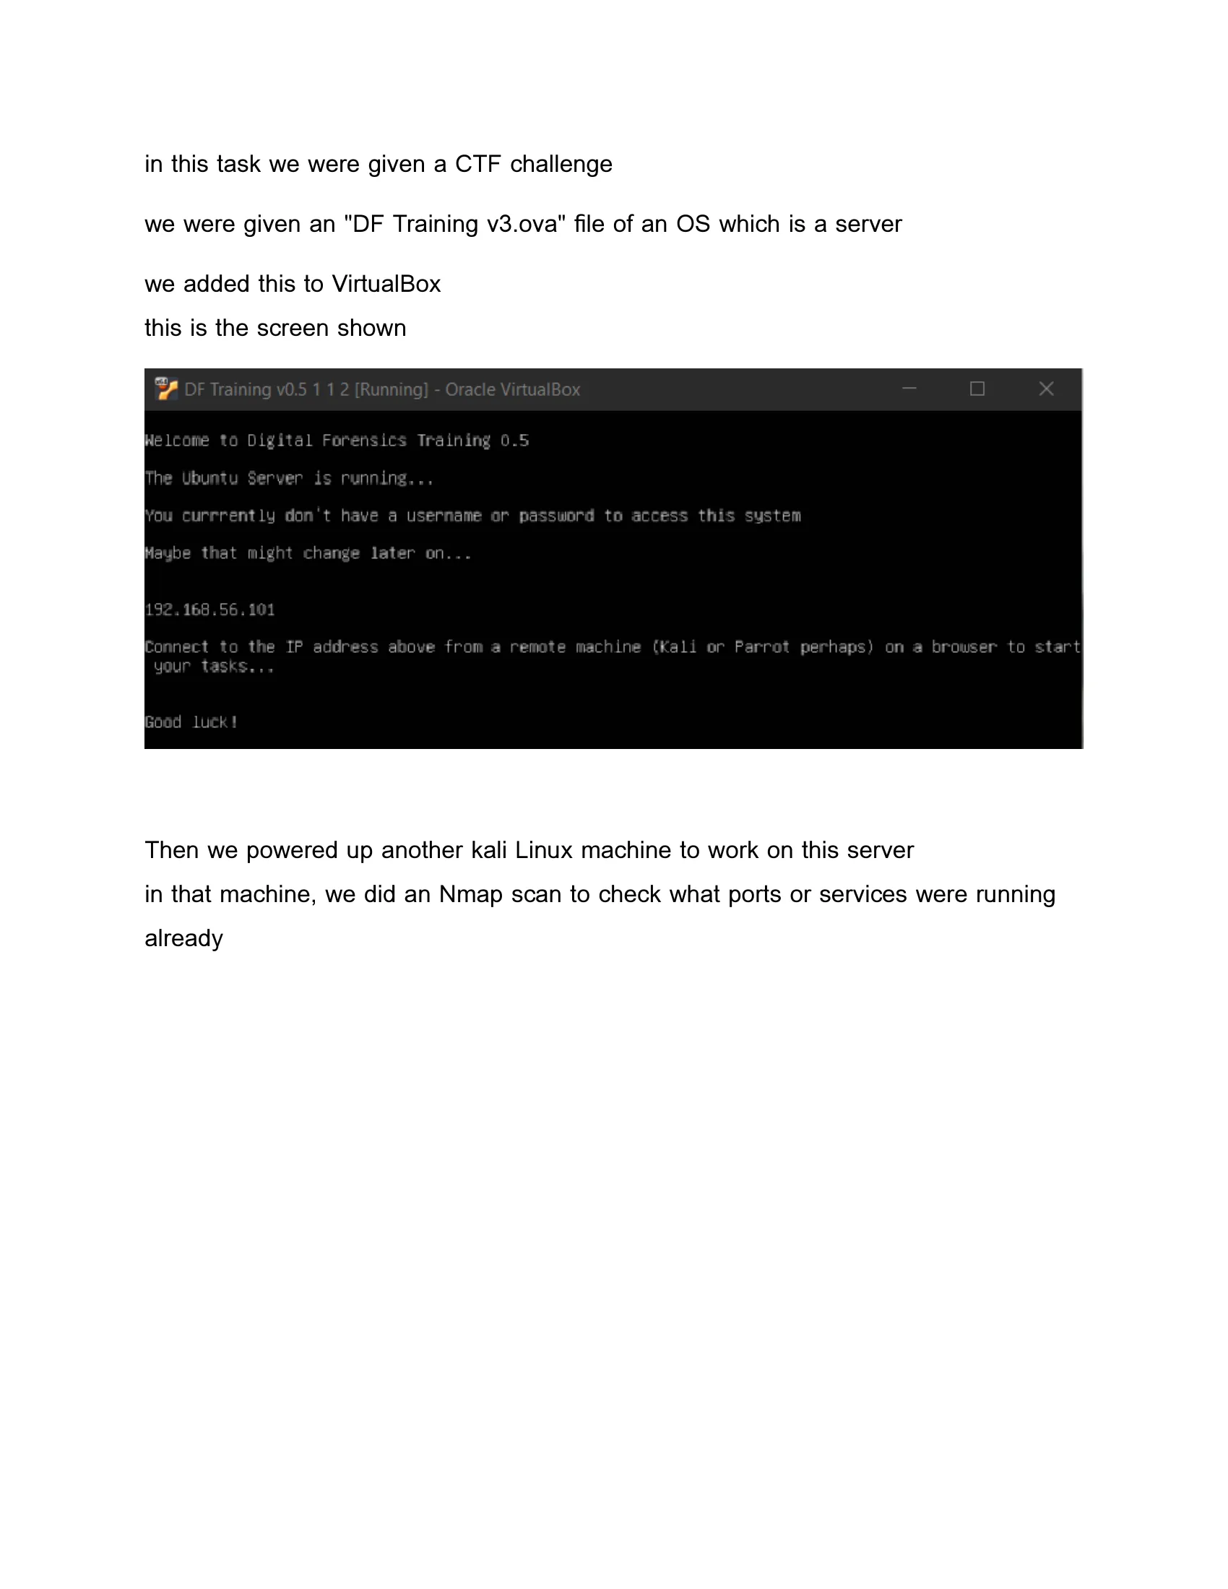

*Figure 1: The target server's console upon initial boot.*

* Attack Machine: For our offensive operations, we utilized a standard Kali Linux virtual machine [3]. Kali Linux comes pre-installed with a vast suite of penetration testing tools, which provided us with the arsenal needed to conduct reconnaissance, enumeration, and exploitation.

Both virtual machines were configured to use the same internal network, allowing the Kali machine to communicate directly with the target server.

## 2.2. Arsenal: Tools and Resources

Throughout the challenge, we leveraged a combination of built-in utilities and specialized open-source tools. The selection of appropriate tools is a critical skill in penetration testing, as different scenarios require different approaches. Our primary toolkit included:

**Nmap (Network Mapper):** An indispensable tool for network discovery and security auditing. Nmap is considered the industry standard for port scanning and service detection. We used it for initial port scanning with default settings and later performed a more comprehensive deep scan using the -p- flag to scan all 65,535 TCP ports and the -sC flag to run default scripts for service enumeration [4]. The ability to customize Nmap scans based on the situation is a fundamental skill for any penetration tester.

**Hydra:** A powerful and fast network logon cracker that supports numerous protocols including FTP, SSH, HTTP, and many others. We employed Hydra to brute-force the password for the FTP service using a dictionary attack approach [5]. Hydra's speed and versatility make it an essential tool for testing password strength across various network services. The tool's ability to parallelize login attempts significantly reduces the time required to crack weak passwords.

**Dirb:** A web content scanner specifically designed to discover hidden files and directories on web servers. Dirb operates by launching dictionary-based attacks against a web server and analyzing the responses. We used it with its default wordlist, which contains common directory and file names [6]. This type of enumeration is crucial for expanding the attack surface of a web application and often reveals administrative interfaces, backup files, or other sensitive resources that were not intended to be publicly accessible.

**Python:** For the cryptographic challenge, we wrote a custom Python script using the hashlib library to perform a brute-force attack against the provided MD5 and SHA1 hashes [7]. Python's extensive standard library and ease of use make it an ideal language for quickly developing custom security tools and automation scripts. The ability to write custom code is invaluable when facing challenges that don't have ready-made solutions.

**SecLists:** For the FTP brute-force attack, we used a common password list from the SecLists repository, specifically the 500-worst-passwords.txt file [8]. SecLists is a comprehensive collection of multiple types of lists used during security assessments, including usernames, passwords, URLs, fuzzing payloads, and more. It is maintained by Daniel Miessler and is widely used in the security community.

**Standard Linux Utilities:** We made extensive use of the command line, including ftp for file transfer protocol operations, ssh for secure shell access, cat for displaying file contents, ls for listing directory contents, and various other commands for interaction with the target system. Proficiency with Linux command-line tools is essential for any cybersecurity professional, as many security operations are performed in terminal environments.

# 3. Execution and Detailed Walkthrough

Our approach was methodical, following the standard phases of a penetration test. We documented each step with screenshots to maintain a clear chain of evidence.

## 3.1. Phase 1: Initial Reconnaissance and Enumeration

With the environment set up, our first action was to perform a basic reconnaissance scan on the target IP address using Nmap.

nmap 192.168.56.101

The scan quickly revealed three open ports:

* 21/tcp (FTP): File Transfer Protocol
* 22/tcp (SSH): Secure Shell
* 80/tcp (HTTP): Hypertext Transfer Protocol

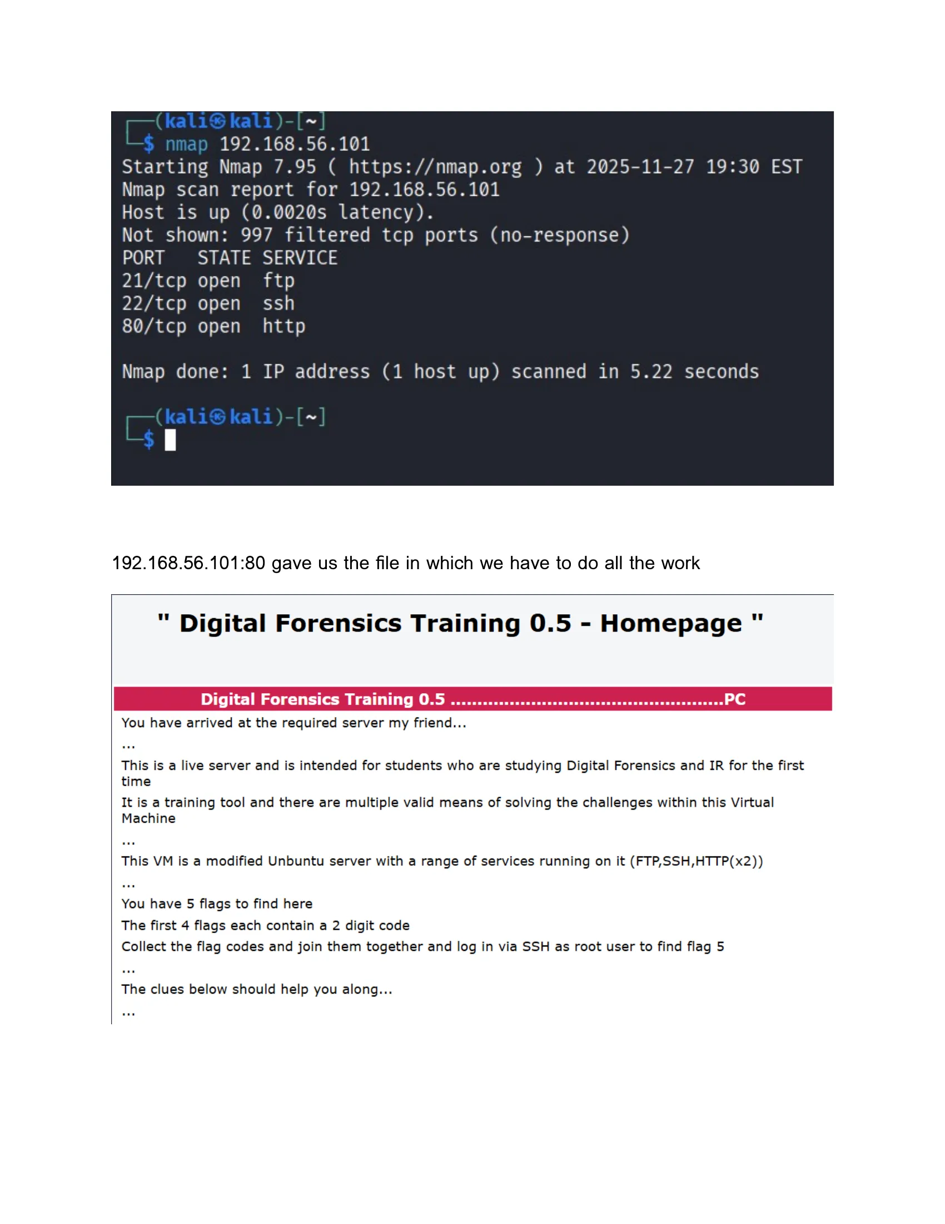

*Figure 2: Results of our initial Nmap scan, showing open ports.*

We decided to investigate the HTTP service first, as it is often a rich source of information. Navigating to http://192.168.56.101 in a web browser presented us with the challenge's homepage. This page explicitly laid out the objective: find five flags, with the first four providing a code to unlock the fifth. This was a critical piece of intelligence that guided our entire strategy.

## 3.2. Phase 2: Capturing Flag 1 - The Cryptographic Puzzle

The homepage led us directly to the first challenge. It presented us with an MD5 hash (b6d767d2f8ed5d21a44b0e5886680cb9) and a SHA1 hash (12c6fc06c99a462375eeb3f43dfd832b08ca9e17). The clue stated that these hashes corresponded to a two-digit number between 00 and 99. This was fundamentally a cryptographic challenge that required us to understand hash functions and their vulnerabilities.

Hash functions are one-way mathematical algorithms that convert input data of any size into a fixed-size output, called a hash or digest. MD5 (Message Digest Algorithm 5) produces a 128-bit hash value, while SHA1 (Secure Hash Algorithm 1) produces a 160-bit hash value. Both are considered cryptographically broken for security purposes today, but they are still widely used for checksums and non-security applications. The key vulnerability we were exploiting here was the small keyspace—only 100 possible values—which made a brute-force attack trivial.

To solve this, we decided to write a simple Python script to brute-force the answer. The script iterated through all numbers from 0 to 99, formatted them as two-digit strings (e.g., "01", "22"), calculated the MD5 and SHA1 hashes for each, and compared them to the target hashes. The logic was straightforward: for each candidate number, we would compute both hashes and check if they matched the provided target values. If both matched, we had found our answer.

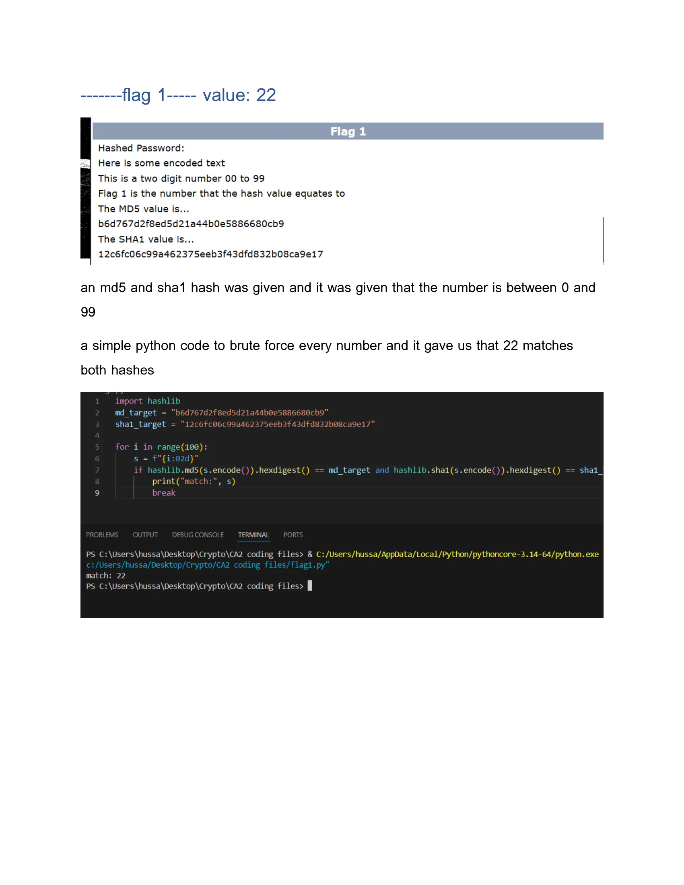

*Figure 3: The Python script we wrote to solve the hash challenge and its output.*

Our script quickly found a match for the number 22. This was our first flag.

**Flag 1 Value: 22**

## 3.3. Phase 3: Capturing Flag 2 - FTP Service Exploitation

The next clue pointed us toward the FTP server on port 21. It mentioned a user named "test" with a "simple and underwhelming" password. This immediately suggested a brute-force attack. We chose to use Hydra, a well-known password cracking tool, along with a list of common passwords.

We used the following command, targeting the FTP service with the username "test" and the 500-worst-passwords.txt wordlist from SecLists:

hydra -l test -P 500-worst-passwords.txt ftp://192.168.56.101

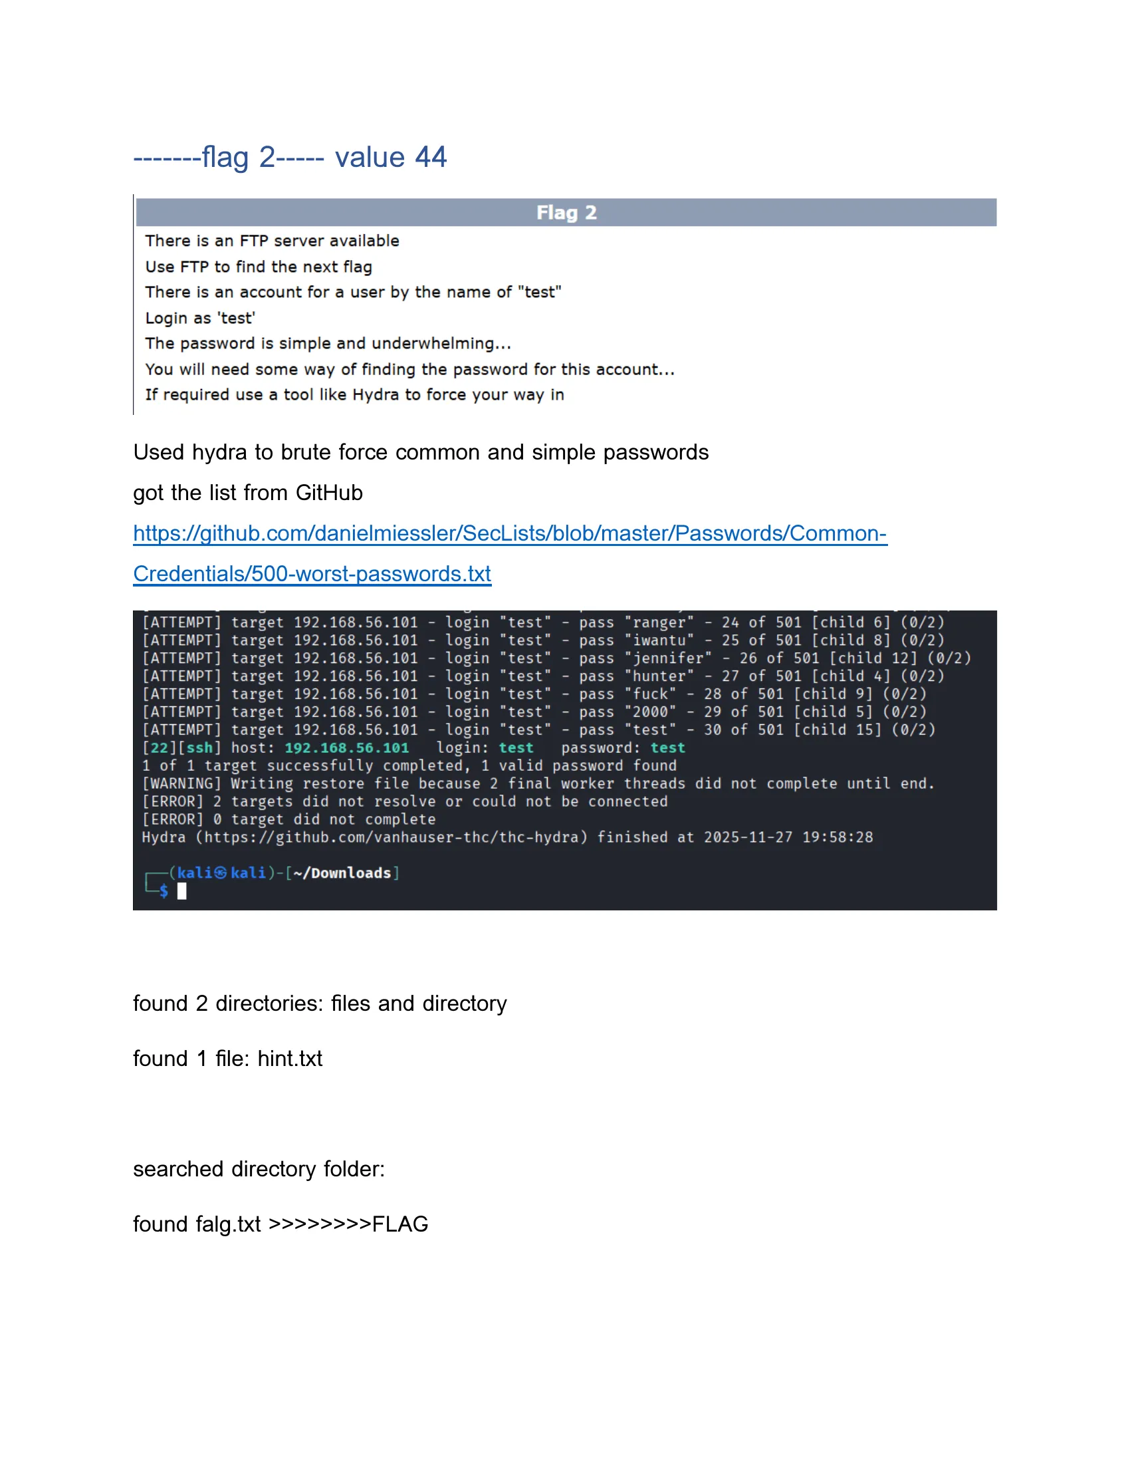

*Figure 4: Hydra successfully cracking the FTP password.*

Hydra made short work of the challenge, correctly identifying the password as test. With these credentials, we logged into the FTP server. We found two directories, files and directory, and a file named hint.txt. We first explored the directory folder and found a file named falg.txt. However, its content revealed it to be a "TOTAL FALSE FLAG," a clever misdirection.

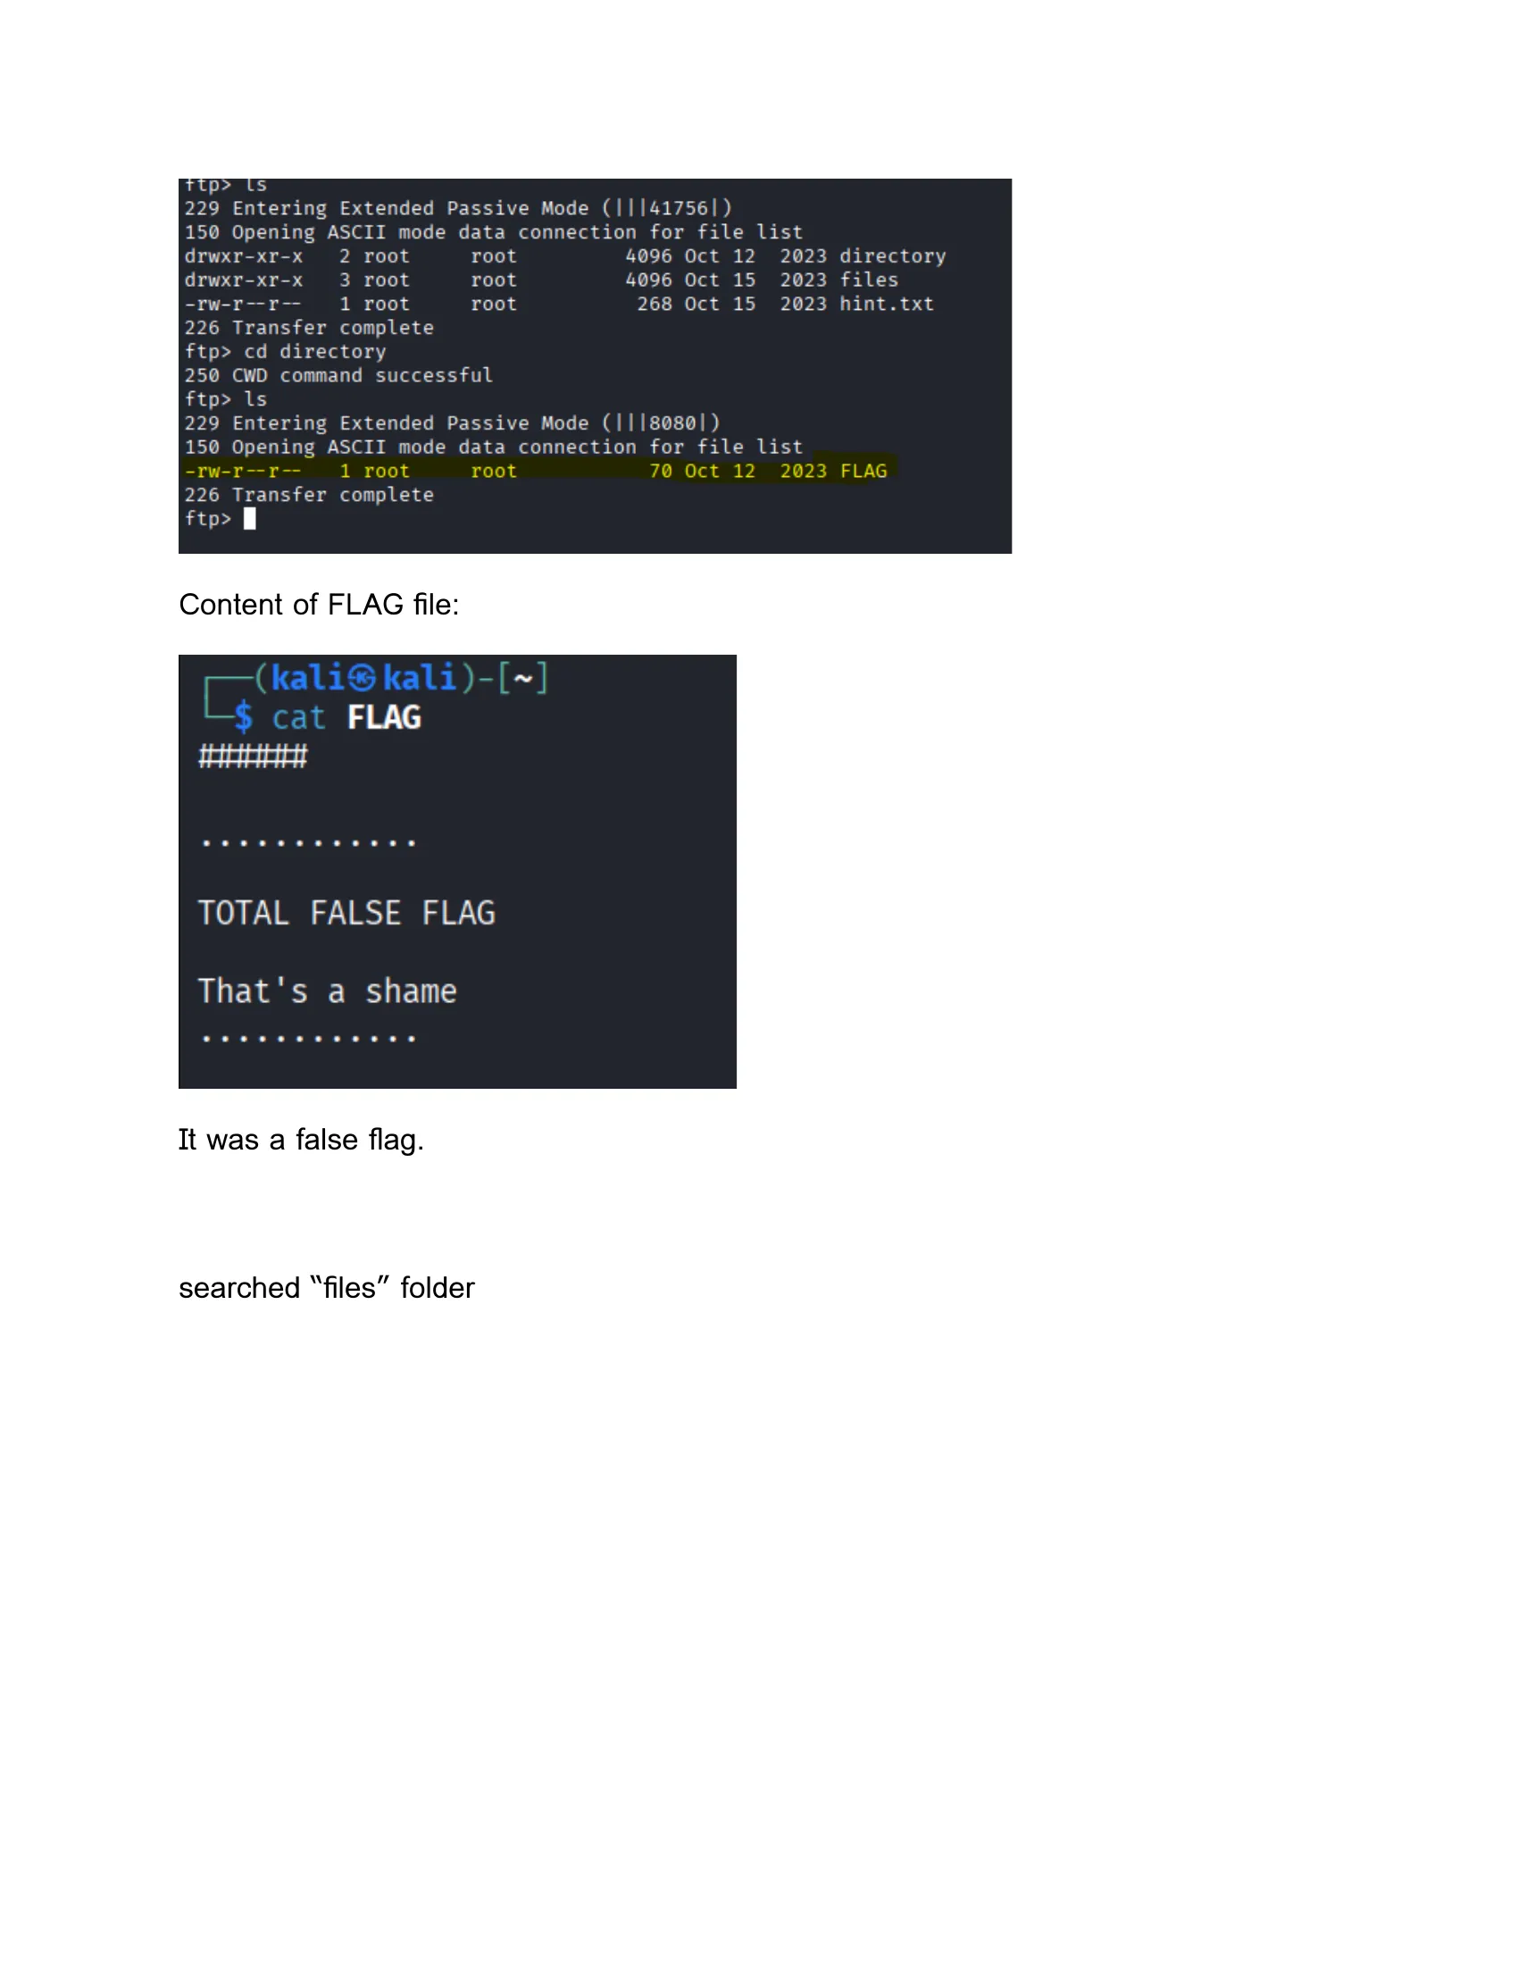

*Figure 5: The contents of the decoy flag file.*

We then turned our attention to the files directory. It contained a large number of files, but one stood out: FLAG2.txt. We downloaded the file using the get command and examined its contents.

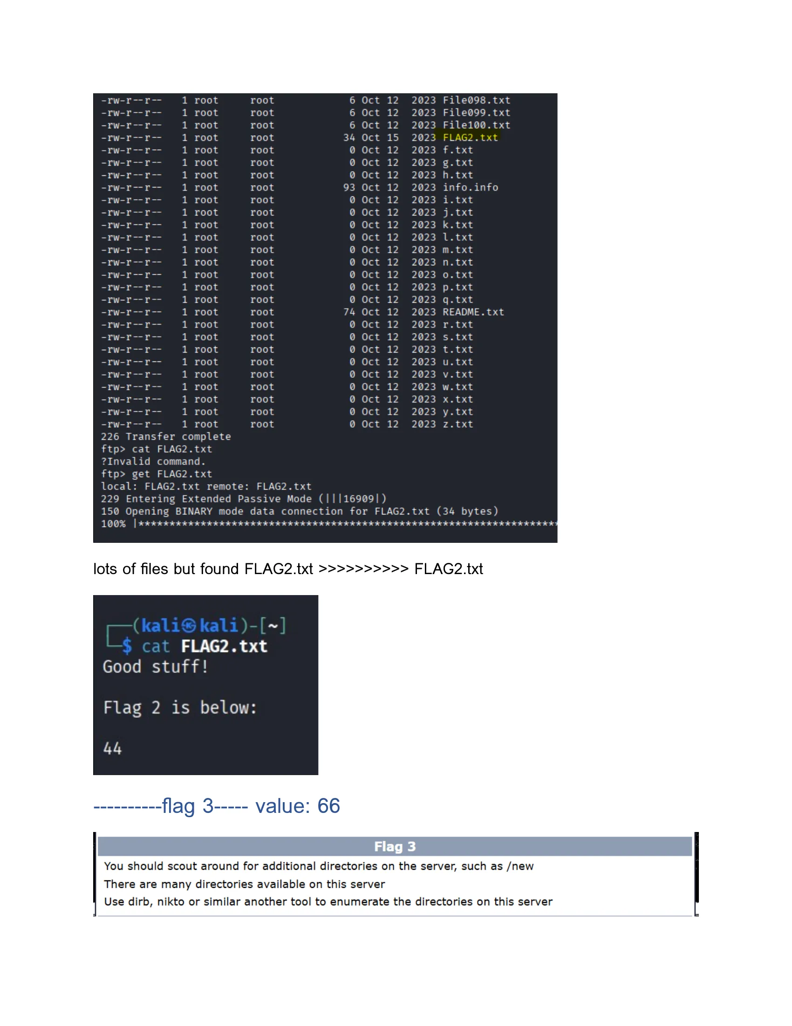

*Figure 6: The contents of FLAG2.txt, revealing the second flag value.*

The file contained the number 44.

**Flag 2 Value: 44**

## 3.4. Phase 4: Capturing Flag 3 - Web Application Reconnaissance

The clue for the third flag advised us to "scout around for additional directories on the server." This was a clear directive to perform web directory enumeration. We used the tool dirb for this purpose.

dirb http://192.168.56.101

dirb scanned the server using a common wordlist and uncovered several hidden directories, including /admin, /php, /python, and /secret.

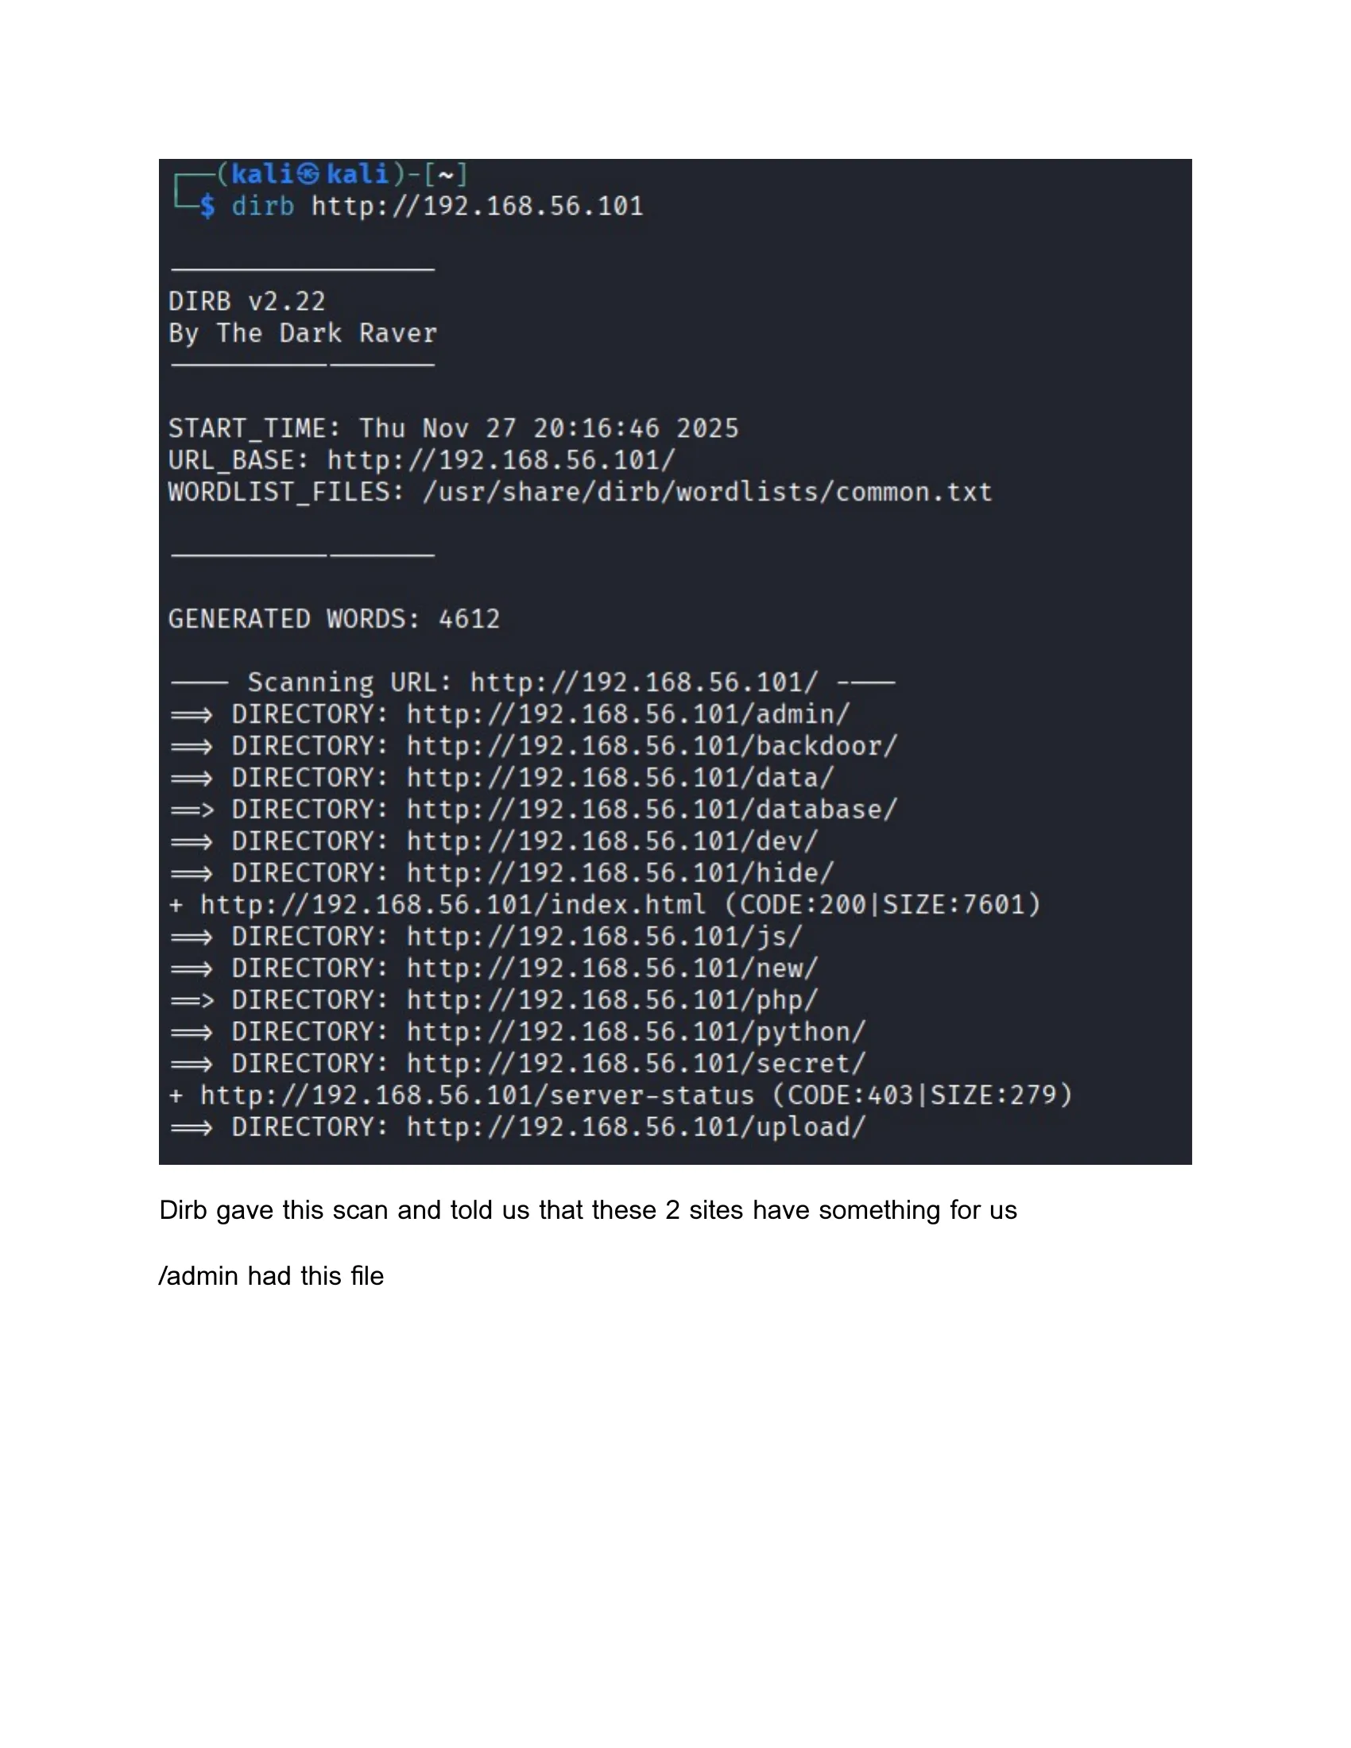

*Figure 7: Dirb discovering hidden directories on the web server.*

We began exploring these directories. A file within the /admin directory hinted that we should look for scripts. This led us to investigate the /php and /python directories. After some exploration, we discovered a promising path: /php/readme/FLAG/FLAG3.txt. Accessing this URL in the browser gave us our third flag.

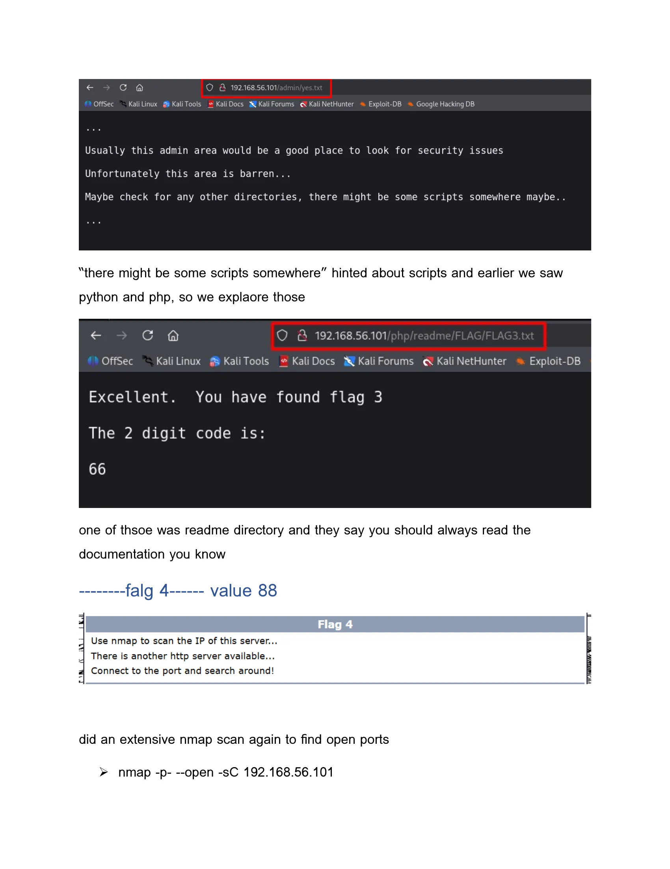

*Figure 8: The web page containing the third flag.*

The page displayed the number 66.

**Flag 3 Value: 66**

## 3.5. Phase 5: Capturing Flag 4 - Advanced Port Scanning and Source Code Analysis

The fourth challenge instructed us to perform another, more thorough nmap scan, suggesting that another HTTP server was available. This time, we performed a scan of all 65,535 TCP ports.

nmap -p- --open -sC 192.168.56.101

This comprehensive scan took longer but yielded a critical discovery: an unknown service running on port 14545.

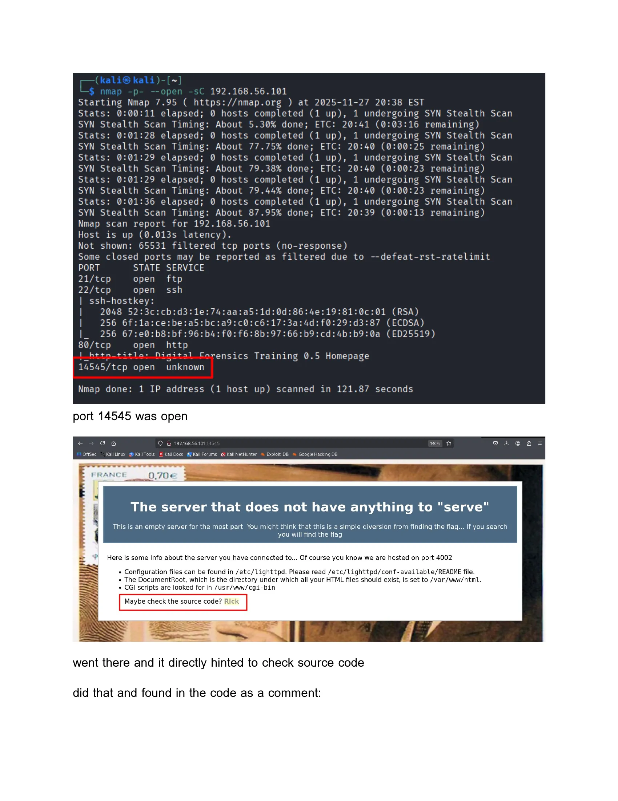

*Figure 9: The full Nmap scan revealing the hidden service on port 14545.*

We connected to this port with our web browser (http://192.168.56.101:14545). The page itself was sparse, but it contained a hint: "Maybe check the source code? Rick." We viewed the page's HTML source code and found the flag hidden inside a comment block.

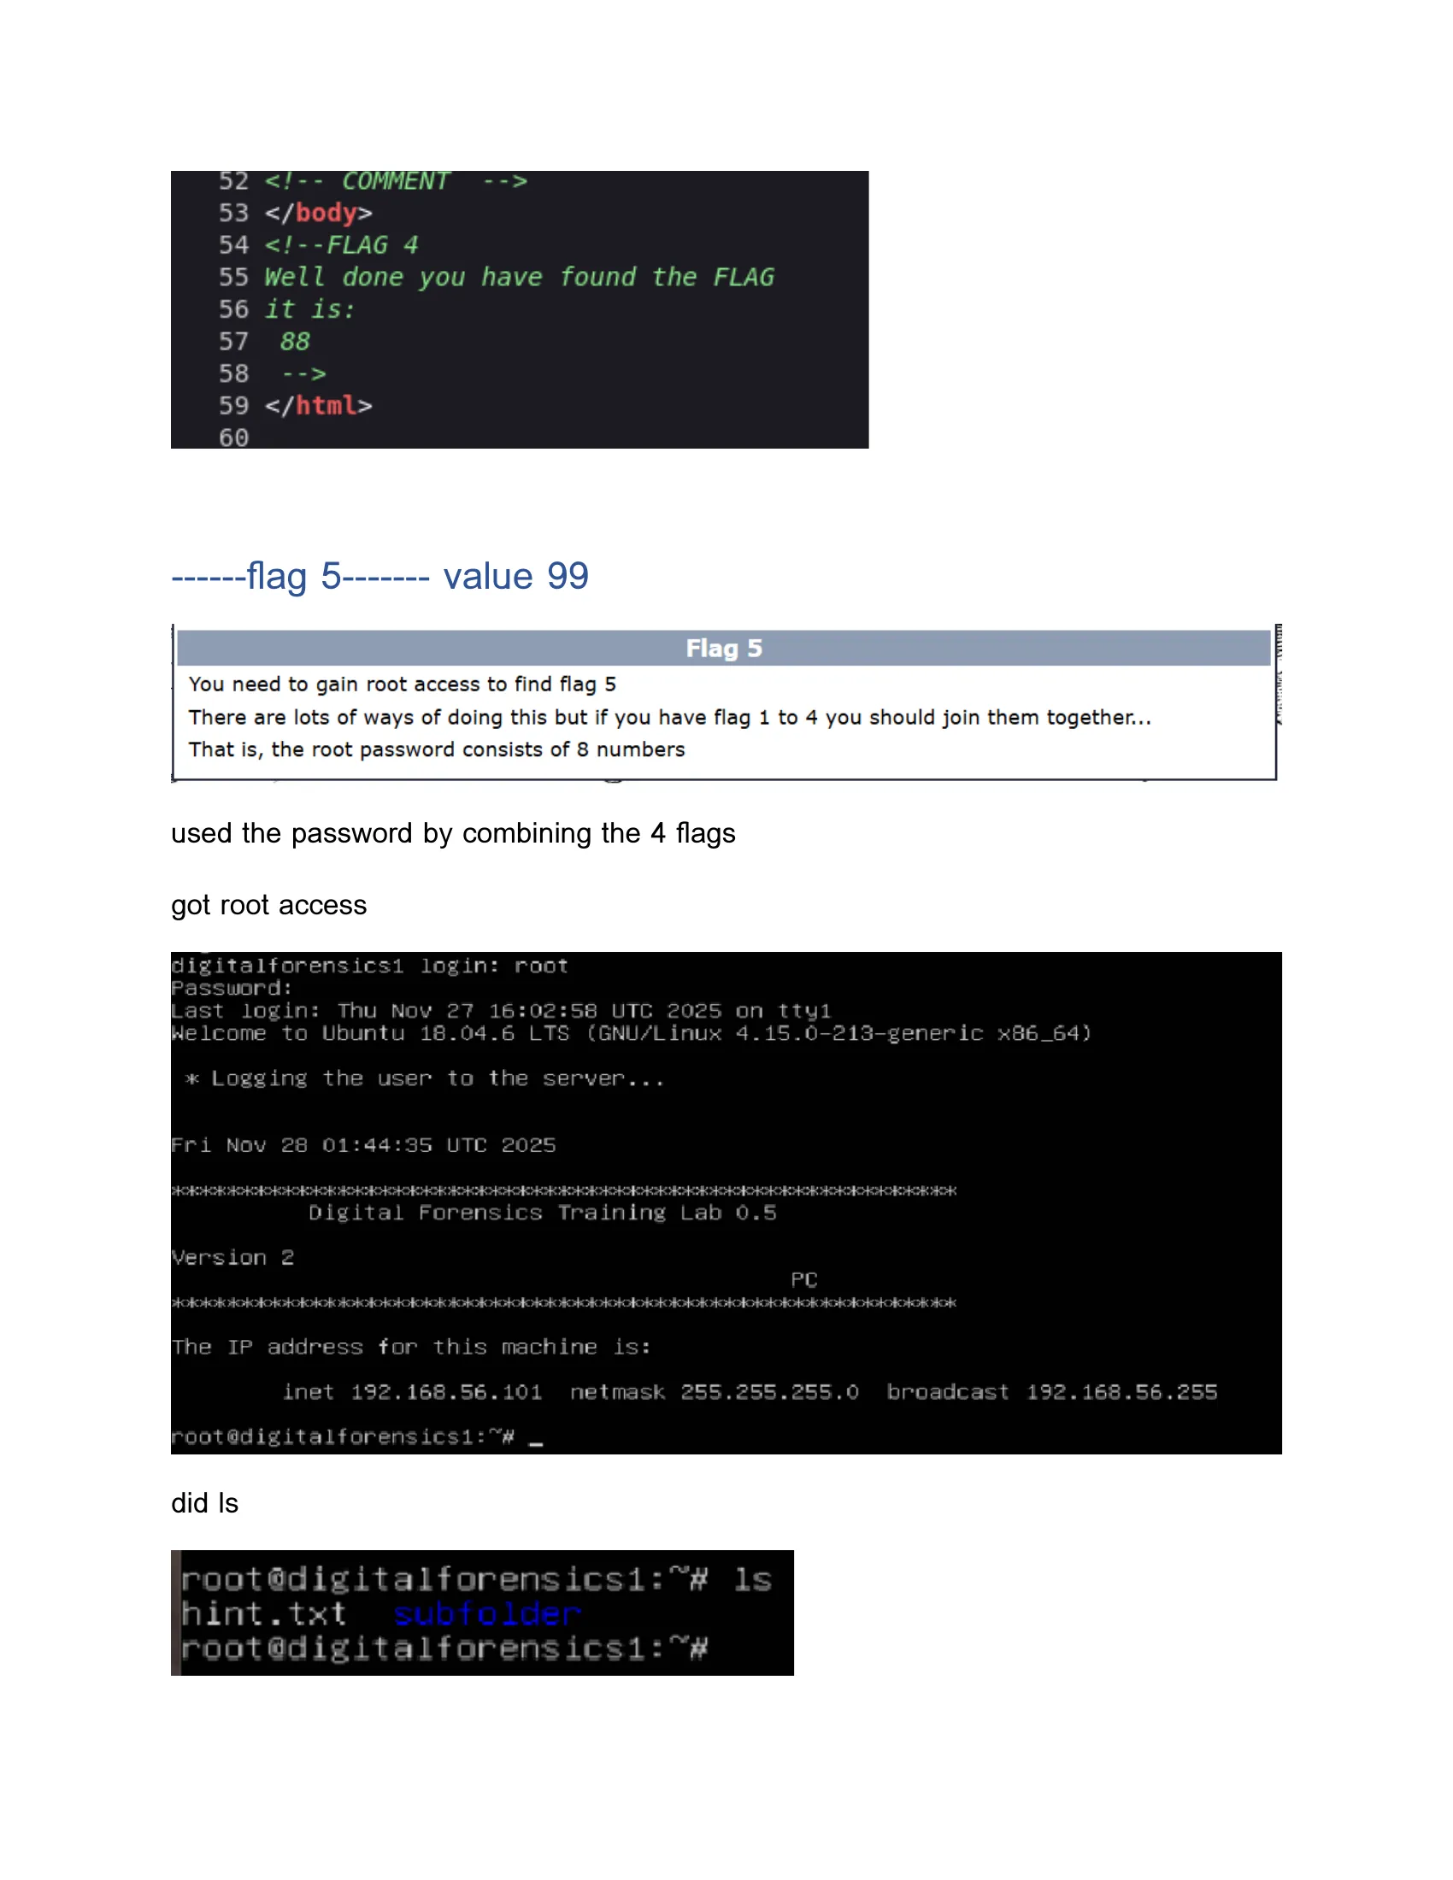

*Figure 10: The HTML source code comment revealing the fourth flag.*

The hidden comment contained the number 88.

**Flag 4 Value: 88**

## 3.6. Phase 6: Capturing Flag 5 - Privilege Escalation and Final Compromise

We now had all four two-digit codes: 22, 44, 66, and 88. As per the initial instructions, we concatenated them to form the 8-digit root password: 22446688. We then attempted to log in as the root user via SSH.

ssh root@192.168.56.101

The password worked, and we were granted a root shell on the target server. We had successfully escalated our privileges to the highest level.

Our final task was to find Flag 5. After a brief search of the root user's home directory, we found a subfolder and inside it, a file named FLAG. We displayed its contents.

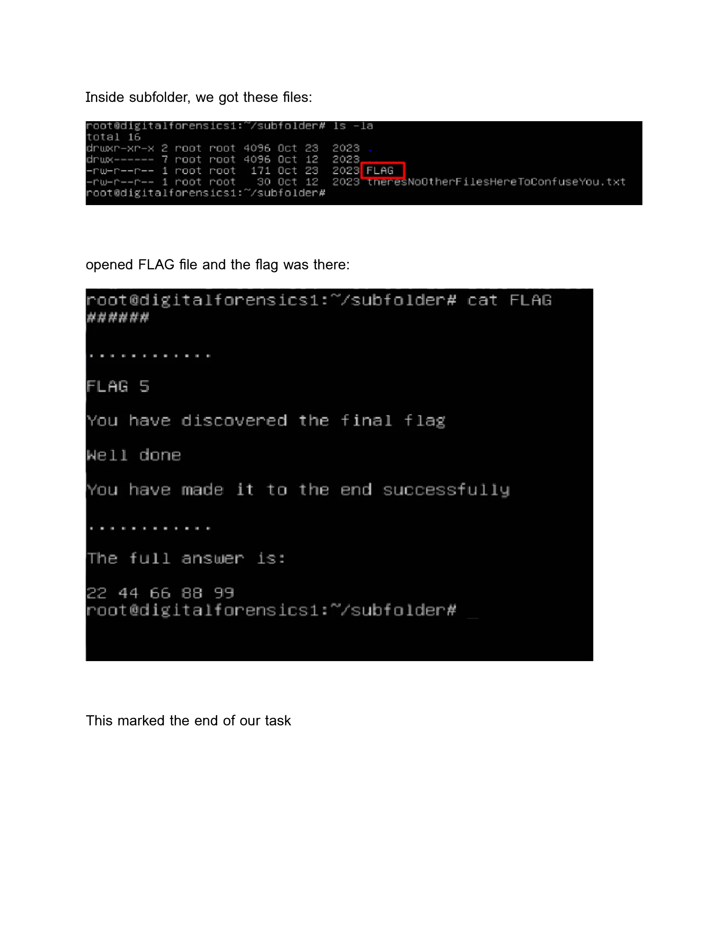

*Figure 11: The contents of the final flag file.*

The file confirmed our success and revealed the final number, 99, completing the full sequence: 22 44 66 88 99.

**Flag 5 Value: 99**

# 4. Results and Key Findings

Our systematic approach led to the successful completion of all objectives.

## 4.1. Summary of Discovered Flags

|  |  |  |
| --- | --- | --- |
| Flag Number | Value | Method of Discovery |
| 1 | 22 | Brute-force of MD5 and SHA1 hashes using a custom Python script. |
| 2 | 44 | FTP password cracking with Hydra, followed by file system analysis. |
| 3 | 66 | Web directory enumeration with Dirb and exploration of hidden paths. |
| 4 | 88 | Full TCP port scan with Nmap and analysis of HTML source code. |
| 5 | 99 | Privilege escalation via SSH using a password constructed from previous flags. |

## 4.2. Analysis of Exploited Vulnerabilities

This challenge exposed a series of common vulnerabilities:

**Weak Hashing Implementation:** The first flag relied on hashing a very small keyspace (100 possibilities), making it trivial to brute-force.

**Weak Password Policy:** The "test" user on the FTP server used an extremely common and weak password ("test"), which was easily guessed by a dictionary attack.

**Information Disclosure:** The web server was improperly configured, exposing hidden directories and files that contained sensitive information, including a flag.

**Insecure Configuration:** The fourth flag was hidden in an HTML comment, a classic example of developers leaving sensitive information in publicly accessible code.

**Obscurity as Security:** A service was running on a non-standard, high-numbered port (14545), a common but ineffective attempt to hide it from casual scanning.

# 5. Discussion and Learning Outcomes

This CTF was more than just a technical exercise; it was a significant learning experience.

## 5.1. Technical Skills and Competencies Developed

This CTF challenge served as a comprehensive practical examination of numerous cybersecurity competencies. Through this challenge, we gained hands-on experience with:

**Reconnaissance and Information Gathering:** We learned to use Nmap for both basic and advanced port scanning, understanding the difference between a quick scan for common ports and an exhaustive scan of all possible ports. This phase taught us the importance of thorough enumeration, as the discovery of port 14545 in our second scan was critical to finding Flag 4. We also learned to interpret Nmap's output, including service versions and potential vulnerabilities indicated by script scans.

**Brute-Force Attacks and Password Security:** We applied Hydra for password cracking against the FTP service, learning how to configure the tool with appropriate wordlists and target specifications. We also wrote a custom Python script for a cryptographic challenge, which reinforced our understanding of hash functions and the importance of keyspace size in security. This experience highlighted the real-world implications of weak passwords and poor password policies.

**Web Application Analysis and Enumeration:** We used Dirb to systematically map out a web server's directory structure, discovering hidden paths that were not linked from the main page. This taught us that security through obscurity is not effective security. We also learned to analyze HTML source code for information disclosure, finding Flag 4 hidden in a comment—a reminder that developers sometimes leave sensitive information in places they assume users won't look.

**Command-Line Proficiency and System Navigation:** Throughout the challenge, we interacted extensively with FTP and SSH services and navigated a Linux file system remotely. This reinforced our command-line skills and our ability to work efficiently in a terminal environment, which is essential for cybersecurity work. We learned to use commands like ls, cd, cat, get, and others in the context of a real penetration test.

**Privilege Escalation and Access Control:** Perhaps most importantly, we learned how to leverage gathered information to gain higher levels of access. The final phase of the challenge, where we combined the four flag values to construct the root password, demonstrated the concept of privilege escalation and the importance of protecting sensitive credentials. This experience gave us insight into how attackers chain together multiple pieces of information to compromise systems.

**Critical Thinking and Problem-Solving:** Beyond specific technical skills, this challenge honed our ability to think critically and solve problems creatively. When we encountered the false flag, we had to reassess our approach and continue searching. When hints were vague, we had to interpret them and decide on the best course of action. These soft skills are just as important as technical knowledge in cybersecurity.

## 5.2. Challenges, Problem-Solving, and Team Dynamics

One of the most significant challenges we encountered was the false flag in the FTP server. It was a valuable lesson in not taking findings at face value and the importance of thoroughness. When we initially found falg.txt (note the deliberate misspelling), there was a moment of excitement followed by confusion when we read its contents declaring it a "TOTAL FALSE FLAG." This was a clever psychological element of the challenge, designed to test our persistence and attention to detail. We had to regroup, re-examine the file system, and realize that we needed to keep looking. This reinforced the need for critical thinking and persistence—traits that are absolutely essential in real-world cybersecurity work, where dead ends and false leads are common.

Another challenge was interpreting the sometimes vague hints provided throughout the challenge. For example, the hint to "check the source code" required us to understand that this meant viewing the HTML source of the webpage, not looking for server-side code. Similarly, the instruction to look for "scripts" in the admin area hint required us to connect this to the /php and /python directories we had discovered. These moments of ambiguity forced us to think creatively and consider multiple interpretations.

Working as a team was crucial to our success. We were able to bounce ideas off one another, with different members taking the lead on tasks that aligned with their strengths and interests. For instance, one member focused on writing the Python script for the hash cracking challenge while another configured and ran the Dirb scan, which allowed us to work more efficiently and in parallel. We held regular check-ins to share our findings and discuss our next steps, ensuring that everyone was aligned and that we weren't duplicating efforts.

Communication was key. When one team member discovered something important, they immediately shared it with the group. We maintained detailed notes throughout the process, documenting each command we ran, each file we found, and each piece of information we uncovered. This documentation not only helped us stay organized during the challenge but also formed the basis for this report. The collaborative nature of this exercise mirrored real-world security teams, where specialists in different areas must work together to achieve a common goal.

Time management was another important consideration. Some tasks, like the comprehensive Nmap scan, took several minutes to complete. During these waiting periods, we didn't sit idle; instead, we worked on other aspects of the challenge or discussed our strategy for the next steps. This efficient use of time was crucial in completing the challenge within a reasonable timeframe.

# 6. Conclusion

The "Digital Forensics Training 0.5" CTF challenge provided an engaging and highly educational experience. By successfully navigating through its five stages, we were able to apply a wide range of penetration testing techniques in a practical context. We moved from initial network scanning to cryptographic analysis, password cracking, web enumeration, and finally, successful root-level privilege escalation. The challenge was well-designed, with each flag requiring a different skillset and a logical progression that mirrored a real-world security assessment. This hands-on exercise has not only solidified our technical skills but has also enhanced our problem-solving abilities and our capacity for effective teamwork. It stands as a testament to the value of practical, gamified learning in the complex and ever-evolving field of cybersecurity.

# 7. References

[1] D. G. Kartasasmita, F. G. C. Timur, and A. H. Reksobrodjo, "Enhancing Competency of Cybersecurity Through Implementation of the 'CAPTURE THE FLAG' On College in Indonesia," International Journal Of Humanities Education And Social Sciences (IJHESS), vol. 3, no. 2, pp. 875–890, Oct. 2023.

[2] Oracle Corporation, "Oracle VM VirtualBox," 2023. [Online]. Available: https://www.virtualbox.org

[3] Offensive Security, "Kali Linux," 2023. [Online]. Available: https://www.kali.org

[4] Nmap.org, "Nmap: The Network Mapper," 2023. [Online]. Available: https://nmap.org

[5] van Hauser, T., "THC-Hydra," 2023. [Online]. Available: https://github.com/vanhauser-thc/thc-hydra

[6] The Dark Raver, "Dirb," 2023. [Online]. Available: http://dirb.sourceforge.net

[7] Python Software Foundation, "Python Language Reference," 2023. [Online]. Available: https://www.python.org

[8] D. Miessler, "SecLists," 2023. [Online]. Available: https://github.com/danielmiessler/SecLists/blob/master/Passwords/Common-Credentials/500-worst-passwords.txt